**Project Title: Learning Management and Training Establishment Model (SAKSHAM)**

* Document Version: 1.0
* Date: 05/03/2024
* Author: Analytics and Infographics
* Reviewers: Dr.Sachin kasat Sir

**Targeted Users:**

* 1. Head of the Departments
  2. Training Resources (Trainer Admins, Trainers, Trainees)
  3. Admins
  4. Other Learning related resources (Discussion forum, blogs(Domain Expertise)

1. **Executive Summary**
   * Overview

The training module is dedicated for the development of a learning portal dedicated to the training department under human resource management. The module can improve the Knowledge enhancement services offered by the MDIndia for internal/external purposes.

* + Purpose
    1. **Enhanced Training Efficiency**: The portal aims to streamline training processes, making them more efficient and effective. By providing a centralized platform for accessing training materials, scheduling sessions, and tracking progress, it reduces administrative burdens and allows trainers to focus more on delivering quality content.
    2. **Knowledge Enhancement**: The primary goal of the portal is to enhance the knowledge and skills of MDIndia employees. Through curated learning resources, interactive modules, and assessments, employees can continuously develop their expertise, keeping pace with industry trends and organizational needs.
    3. **Employee Engagement and Satisfaction**: Investing in employee development through a dedicated learning portal demonstrates MDIndia's commitment to the growth and well-being of its workforce. Engaging training experiences contribute to higher job satisfaction, increased morale, and ultimately, improved employee retention.
    4. **Cost Savings**: By digitizing training materials and processes, the portal reduces the need for traditional classroom-based training, saving both time and resources. Additionally, it enables scalability, allowing MDIndia to reach a larger audience without incurring significant additional costs.
    5. **Alignment with Organizational Goals**: The training portal aligns closely with MDIndia's strategic objectives by ensuring that employees possess the necessary skills and knowledge to drive business success. By fostering a culture of continuous learning and development, it supports innovation, adaptability, and competitiveness in the marketplace.

**Report Overview**

Report Purpose:

The purpose of this report is to inform Learning management and to interpret the data and .

* + **Module Structure:**

**Common**

├── Dashboard

│ ├── Training Conducted Count

│ ├── Total Active Users Count

│ ├── Team Performance

│ ├── Upcoming Events

│ └── Calendar

├── Training Request

│ ├── Create Training Request

│ └── Reply to Request

└── User Profile

├── Profile

├── Change Password

└── Notifications

**HoD**

├── Dashboard

│ ├── Training Conducted Count

│ ├── Total Active Users Count

│ ├── Team Performance

│ ├── Upcoming Events

│ └── Calendar

├── User Profile

│ ├── Profile

│ ├── Change Password

│ └── Notifications

└── Team

├── Employee List

│ └── Employee Details

├── User Wise Performance

├── Verify User

└── Employee Enrollment for Course

**Trainers_Admin**

├── Dashboard

│ ├── Available Trainers Count

│ ├── Training Rooms

│ ├── Calendar

│ ├── Training Conducted

│ ├── Active Employees

│ └── Upcoming Events

├── Training

│ ├── Training Request

│ │ ├── Accept and Reply

│ │ └── Schedule Training

│ │ ├── Training Type: Live

│ │ ├── Training Type: Offline

│ │ └── Training Type: Online/Pre-recorded

│ └── Course Management

│ ├── Create Course

│ ├── Upload Content

│ └── Assignments

├── Exam

│ ├── Create Exam

│ ├── Pre-Training Performance

│ ├── Post-Training Performance

│ └── Attendance

└── Feedback

├── Trainers Feedback

└── Exam Feedback

**Trainers**

├── Dashboard

│ ├── Calendar

│ ├── Upcoming Events

│ └── No of Session Conducted

│ ├── Online

│ └── Offline

├── Training

│ ├── Execute Training

│ └── Rescheduling Training

├── Feedback

│ ├── Training Feedback

│ ├── Trainers Feedback

│ └── Exam Feedback

└── User Profile

├── Profile

├── Change Password

└── Notifications

**Employee**

├── Dashboard

│ └── Upcoming Events

├── My Learning

│ └── Enrolled Courses

│ ├── Earned Badge

│ ├── Completed Status

│ ├── Assignments

│ └── Course Forums

├── Exam

│ ├── All Exam

│ └── Result

└── User Profile

├── Profile

├── Change Password

└── Notifications

Exam module

HoD

├── Dashboard

│ ├── Exam Conducted Count

│ ├── Exam Results Overview

│ ├── Exam Performance Analysis

│ ├── Upcoming Exams

│ └── Exam Calendar

├── User Profile

│ ├── Profile

│ ├── Change Password

│ └── Notifications

└── Exam Management

├── Exam List

│ └── Exam Details

├── Create New Exam

├── Edit Exam Details

├── Delete Exam

├── Assign Exam to Users/Teams

└── Exam Settings

**Module requirements and Features**

|  |  |  |  |  |  |  |
| --- | --- | --- | --- | --- | --- | --- |
|  |  |  |  |  |  |  |
| **Module** | **Functionality** | **Common** | **HoD** | **Trainers_Admin** | **Trainers** | **Employee** |
| Dashboard |  | ✔️ | ✔️ | ✔️ | ✔️ | ✔️ |
|  | Training Conducted Count | ✔️ | ✔️ |  |  |  |
|  | Total Active Users Count | ✔️ | ✔️ |  |  |  |
|  | Team Performance |  | ✔️ |  |  |  |
|  | Upcoming Events | ✔️ | ✔️ | ✔️ | ✔️ | ✔️ |
|  | Calendar | ✔️ | ✔️ | ✔️ | ✔️ | ✔️ |
| Training Request |  | ✔️ |  | ✔️ |  |  |
|  | Create Training Request | ✔️ |  | ✔️ |  |  |
|  | Reply to Request | ✔️ |  | ✔️ |  |  |
| User Profile |  | ✔️ | ✔️ | ✔️ | ✔️ | ✔️ |
|  | Profile | ✔️ | ✔️ | ✔️ | ✔️ | ✔️ |
|  | Change Password | ✔️ | ✔️ | ✔️ | ✔️ | ✔️ |
|  | Notifications | ✔️ | ✔️ | ✔️ | ✔️ | ✔️ |
| Team |  |  |  |  |  |  |
|  | Employee List |  |  |  |  |  |
|  | Employee Details |  | ✔️ |  |  |  |
|  | User Wise Performance |  | ✔️ |  |  |  |
|  | Verify User |  | ✔️ |  |  |  |
|  | Employee Enrollment for Course |  | ✔️ |  |  |  |
| Course Management |  |  |  |  |  |  |
|  | Create Course |  |  | ✔️ |  |  |
|  | Upload Content |  |  | ✔️ |  |  |
|  | Assignments |  |  | ✔️ |  |  |
| Exam |  |  |  |  |  |  |
|  | Create Exam |  |  |  |  |  |
|  | Pre-Training Performance |  |  |  |  |  |
|  | Post-Training Performance |  |  |  |  |  |
|  | Attendance |  |  |  |  |  |
| Feedback |  |  |  |  |  |  |
|  | Trainers Feedback |  |  |  |  |  |
|  | Exam Feedback |  |  |  |  |  |
|  | Questions |  |  |  |  |  |

1. **Data Sources**
   * **Data Connections:**
     + 1. Data is proposed to extract from RDMS and flat files like Excel/
2. **Security**
3. **Maintenance and Updates**
   * **Version Control:**
     + Describe the version control process for the report.
4. **Support and Contacts**
   * **Support Contacts:**
     + Dr. Sachin Kasat Sir
     + Shreyas Adsule
     + Shantanu Kokate
     + Pruthviraj Mohite
     + Amol Sahare
   * **Training Materials:**

**Trainers**

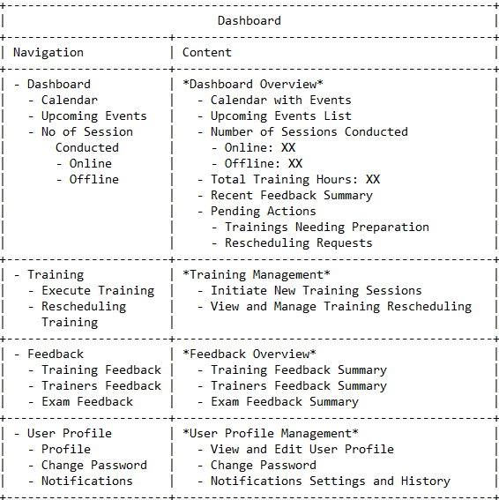

**Employee dashboard**

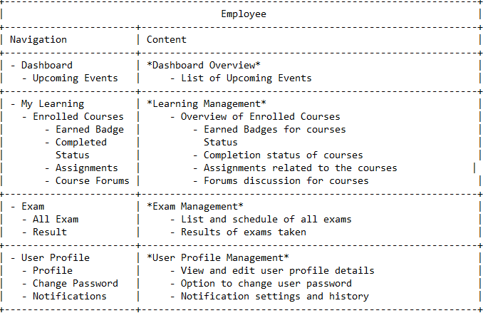

**HOD Dashboard**

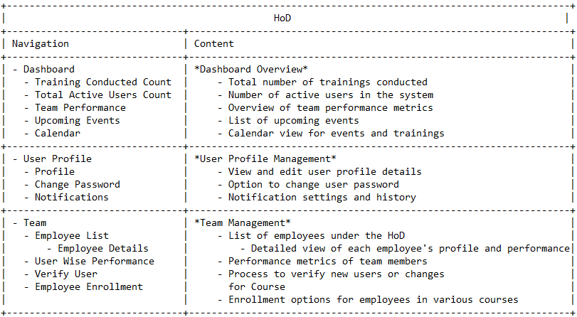

**Common dashboard**

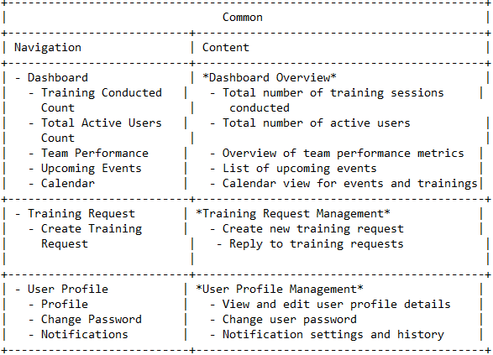

**Data base Design**

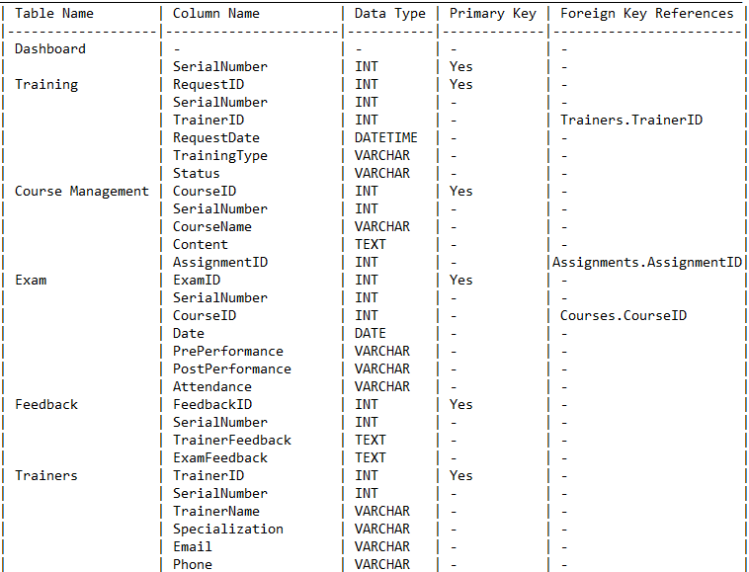

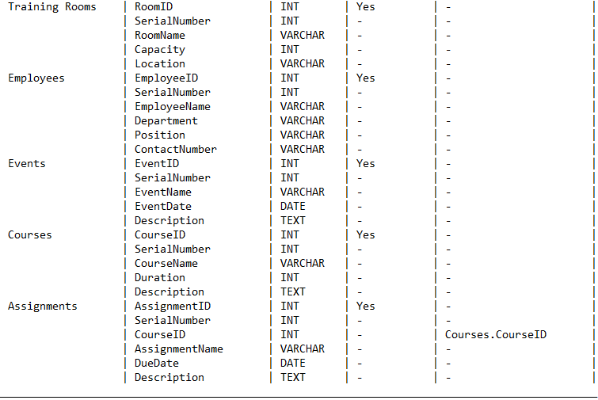

**Review and Approval**

* **Review Date: 05/03/2023**
* **Reviewers: Dr.Sachin Kasat Sir.**
* **Approval:**

**Version History**

* **Version 1.0: 05/03/2024**
* Initial release.